Results
The study group consisted of 100 patients scheduled for coronary angiography & left sided heart catheterization to measure left ventricular end diastolic pressure. Sixty patients were males and forty patients were females. Eighty nine patients were > 65 years old and eleven patients were ≥ 65years old.

Gender:
60 (60%) of patient in our study were males and 40 (40%) were females (figure 1). No statistically significant relation was found between different sex and left ventricular end diastolic pressure (P< 0.05). ( table 2 & figure 19, figure 20).

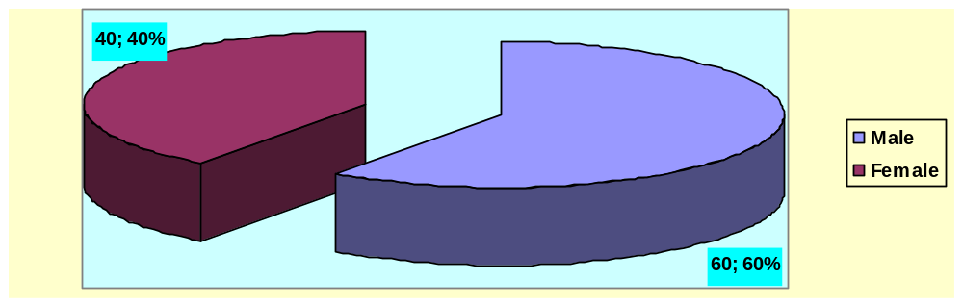
Figure (19): Differentiation of the patients according to
the gender.

Table (2): Differentiation of the patients according to
the gender in relation to left ventricular end diastolic pressure.
MW P | Median | LVEDP  X`±SD (Range) | N | Gender
0.17 0.67  (N. Sig.) | 7.5 | 8.85±7 (1 – 45) | 60 | Male
0.17 0.67  (N. Sig.) | 7 | 10.6±9 (1 – 38) | 40 | Female

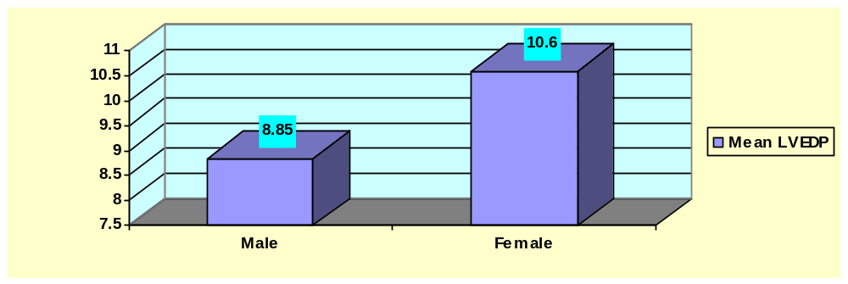Figure (20): Differentiation of the patients according to
the gender in relation to left ventricular end diastolic pressure.

Age:
Patient were classified according to the age in to 2 groups (one group > 65 years old, the other group ≥ 65years old). 89 (89%) patients were > 65 years old. 11 (11%) patients were ≥ 65years old. No statistically significant relation was found between different groups and left ventricular end diastolic pressure (P< 0.05). ( table 3 & figure 21).
Cut off point of age was assumed 65 years old (Levy et al., 2002).

Table (3): Differentiation of the patients according to
the age in relation to left ventricular end diastolic pressure.

t P | Median | LVEDP  X`±SD (Range) | N | Age
0.2 0.83  (N. Sig.) | 7 | 9.48±7.9 (1 – 45) | 89 | 65>
0.2 0.83  (N. Sig.) | 7 | 10±8 (1 – 25) | 11 | ≥ 65

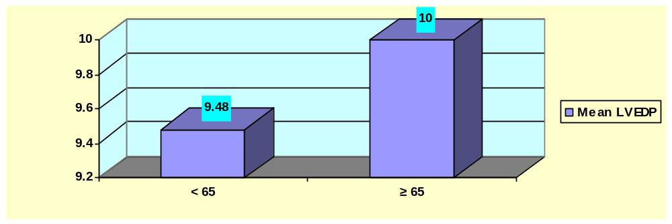Figure (21): Differentiation of the patients according to
the age in relation to left ventricular end diastolic pressure.
3-Risk factors:
* Hypertension;
45 patients were hypertensive (45%) . 55 patients were not (55%).There was statistically significant relation between hypertension and left ventricular end diastolic pressure, as elevated left ventricular end diastolic pressure was noticed in hypertensive patients (P< 0.05). (Table 4 & figure 22).

Table (4): Differentiation of the patients according to
hypertension in relation to left ventricular end diastolic pressure.
MW P | Median | LVEDP  X`±SD (Range) | N | HTN
3.84 0.04  (Sig.) | 6 | 8.1±6.7 (1 – 45) | 55 | ve-
3.84 0.04  (Sig.) | 9 | 11.3±8.8 (1 – 38) | 45 | +ve

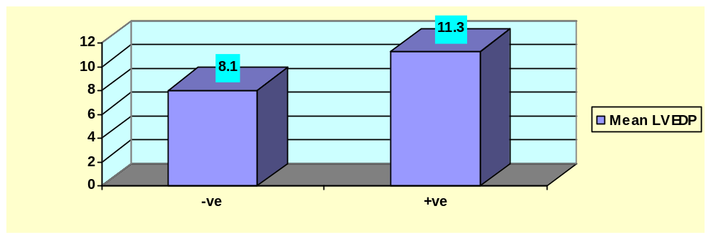 Figure (22): Differentiation of the patients according to
hypertension in relation to left ventricular end diastolic pressure.
*Diabetes mellitus;
48 patients were diabetic (48%). 52 patients were not (52%). There was a statistically significant relation between diabetes mellitus and left ventricular end diastolic pressure, as elevated left ventricular end diastolic pressure was noticed in diabetic patients (P< 0.05). (Table 5 & figure 23).

Table (5): Differentiation of the patients according to
diabetes mellitus in relation to left ventricular end diastolic pressure.
MW P | Median | LVEDP  X`±SD (Range) | N | DM
7.84 0.005  (Sig.) | 6 | 7.2±4.5 (1 – 23) | 52 | -ve
7.84 0.005  (Sig.) | 8.5 | 12.1±9.7 (2 – 45) | 48 | +ve

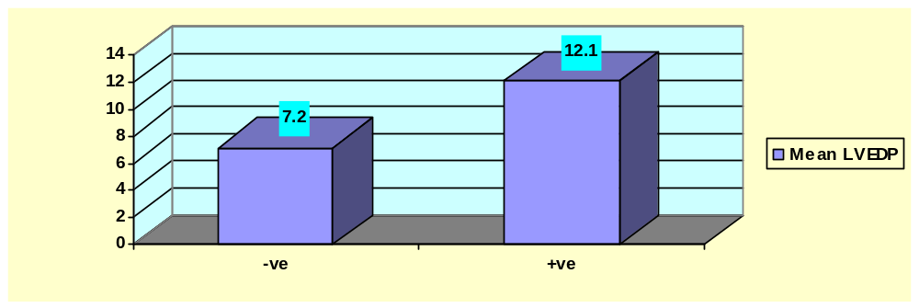Figure (23): Differentiation of the patients according to
diabetes mellitus in relation to Left ventricular end diastolic pressure.

* Smoking;
37 patients were smokers (37%). 63 patients were not (63%). There was a statistically non significant relation between smoking and left ventricular end diastolic pressure (P< 0.05). (Table 6 & figure 24).

Table (6): Differentiation of the patients according to
smoking in relation to left ventricular end diastolic pressure.
MW P | Median | LVEDP  X`±SD (Range) | N | Smoking
0.35 0.55  (N. Sig.) | 7 | 10.4±9.1 (1 – 45) | 63 | -ve
0.35 0.55  (N. Sig.) | 7 | 8.1±4.9 (1 – 25) | 37 | +ve

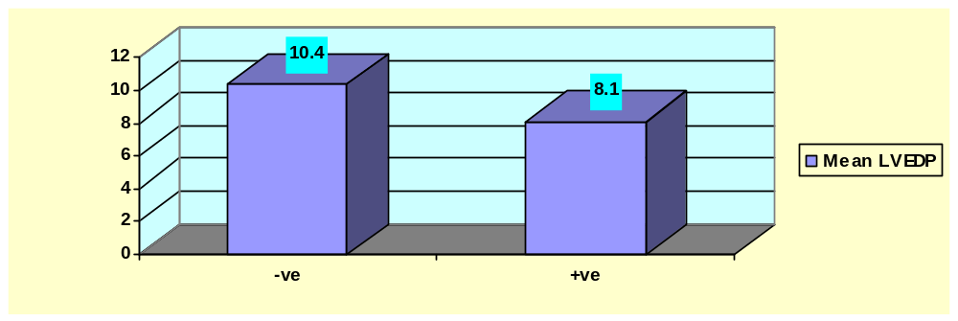 Figure (24): Differentiation of the patients according to
smoking in relation to left ventricular end diastolic pressure

* Coronary artery disease;
Table (7): Differentiation of the patients according to
coronary artery disease in relation to left ventricular end diastolic pressure.
LVEDP  X`±SD (Range) | N | Coronary angiography
4.88±3.032 (1 – 20) | 50 | Normal
10.29±4.783 (5 – 25) | 30 | Non significant lesions
20.25±9.613 (10 – 45) | 20 | Significant lesions
High LVEDP (≥16 ) was observed in 2 individuals with normal coronaries, 3 patients with non significant coronary lesions, 10 patients with significant coronary lesions.
13 of 15 patients (86.6%) with high LVEDP had coronary lesions (significant and non significant),
6 of these 13 patients (46%) had previous MI.
Significant lesions: Lesion more than 50% in left main coronary, lesion more than 70% in left anterior descending coronary or left circumflex coronary or right coronary.
Ischemic diastolic dysfunction is a reversible impairment of myocyte relaxation. The slowing or failure of myocyte relaxation means that a fraction of actin-myosin crossbridges persist and continue to generate tension throughout diastole, especially in early diastole, creating a state of "partial persistent systole.". As a result, left ventricular pressure decay, as assessed by tau, is impaired and the left ventricle is functionally stiffer than normal during diastole ( McKenney et al., 1999).
CORRELATIONS

Correlation between left ventricular end diastolic pressure and different parameters predicting diastolic dysfunction as shown in table (8);
Mean EF (ejection fraction) was 57.5±10.96 (32.9 – 86.7)
Mean E/E´- S (septal) was 9.9±5.6 (3 – 24)
Mean E/E´- L (lateral) was 8.5±5.3 (2.4 – 22.3)
Mean DF (early diastolic driving force) was 0.176±0.17 (0.02 – 0.9)
Mean LVEDP (left ventricular end diastolic pressure) was 9.5±7.8 (1-45)

Table (8): Shows the correlation between end diastolic pressure and different parameters used in the study.
PARAMETER | r | P
EF | -0.48 | >0.001
E/E´- S | 0.85 | 0.001>
E/E´- L | 0.87 | 0.001>
DF | -0.63 | 0.001>

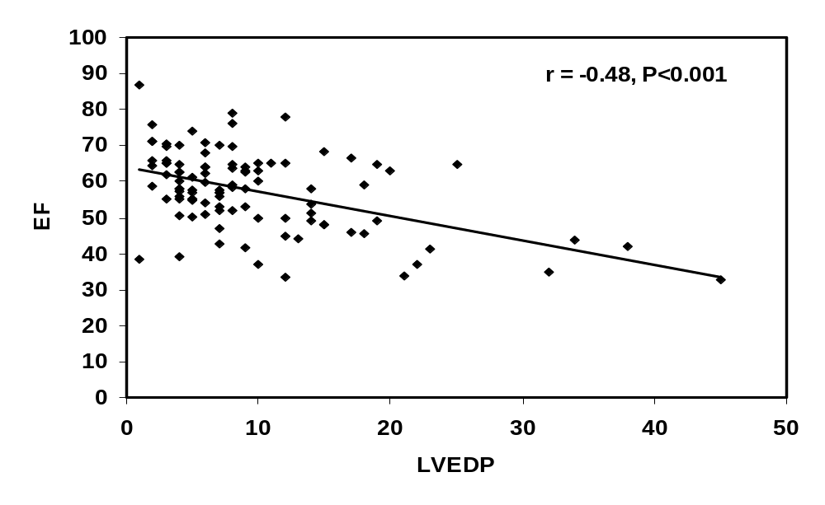Figure (25): Shows a scatter diagram showing negative highly significant correlation between end diastolic pressure (EDP) & Ejection fraction (EF).
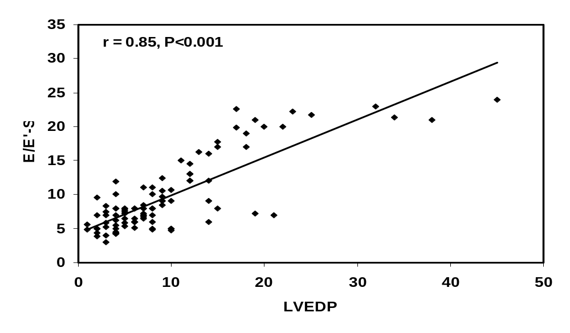
Figure (26): Shows a scatter diagram showing positive highly significant correlation between end diastolic pressure (EDP) & E/E´- S. 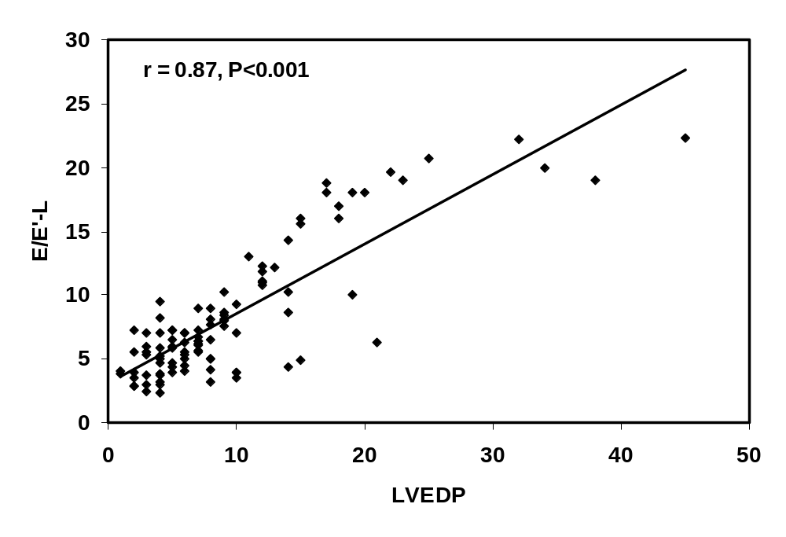
Figure (27): Shows a scatter diagram showing positive highly significant correlation between end diastolic pressure (EDP) & E/E´- L.
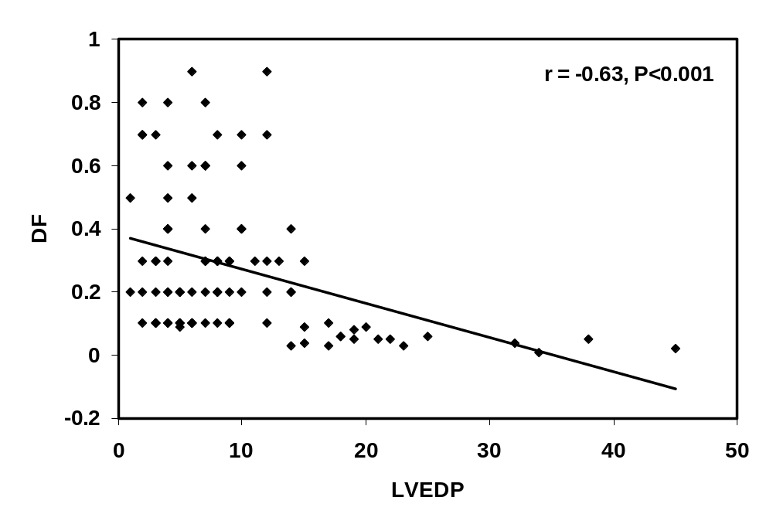
Figure (28): Shows a scatter diagram showing negative highly significant correlation between end diastolic pressure (EDP) & Driving force (DF).

Validity of different parameters used in prediction of left ventricular end diastolic pressure :-
Cut off point of LVEDP was assumed 16 mmHg (Ozer et al., 2011).
- Ejection fraction:
Cut off point of ejection fraction was assumed 50% (Yturralde et al., 2005).
Table (9): Differentiation of the patients according to
the ejection fraction (EF) in relation to left ventricular end diastolic pressure (LVEDP).
LVEDP |  | EF
≥16 | 16>
10 | 12 | 50>
5 | 73 | ≥ 50

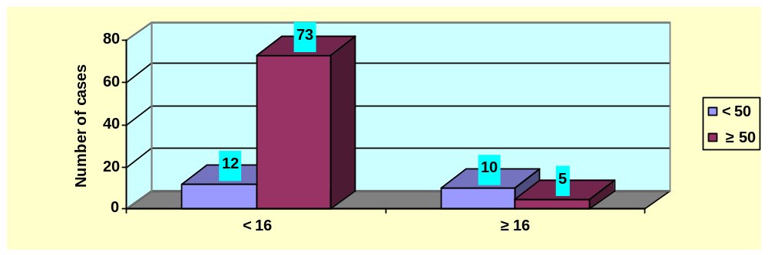Figure (29): Differentiation of the patients according to
the ejection fraction (EF) in relation to left ventricular end diastolic pressure (LVEDP).
Table (10): Validity of ejection fraction in prediction of left ventricular end diastolic pressure.
Validity of EF in prediction of LVEDP
14.1 % | Sensitivity
33.3 % | Specifity
54.5 % | PVP
6.4 % | PVN
17 % | Accuracy

EF: ejection fraction, PVP: predictive value positive, PVN: predictive value negative.

Kappa±SE = 0.19±0.04 {P =0.99}

The table shows low sensitivity, specifity and accuracy of Ejection fraction in prediction of left ventricular end diastolic pressure, so it cannot be used as a predictor for left ventricular end diastolic pressure.

- E/E´- S (septal):
In our study, we proposed that the cut off point of E/E´ is 8 for better estimation of its predictive value for LVEDP.

Table (11): Differentiation of the patients according to
the E/E´- S in relation to left ventricular end diastolic pressure (LVEDP).
LVEDP |  | E/E` – S
≥16 | 16>
2 | 50 | 8>
13 | 35 | ≥ 8

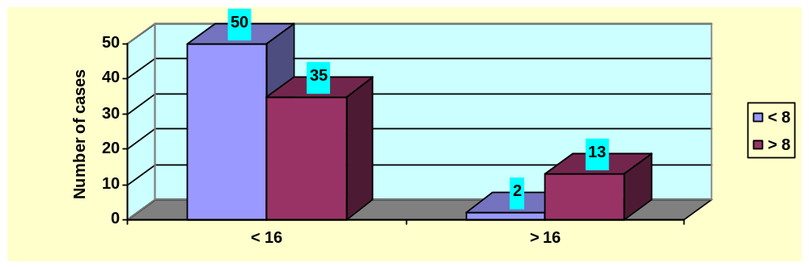
Figure (30): Differentiation of the patients according to
the E/E´- S in relation to left ventricular end diastolic pressure (LVEDP).

Table (12): Validity of E/E´- S in prediction of left ventricular end diastolic pressure.

Validity of E/E` – S in prediction of LVEDP
58.8 % | Sensitivity
86.7 % | Specifity
96.2 % | PVP
27.1 % | PVN
63 % | Accuracy

PVP: predictive value positive, PVN: predictive value negative.

Kappa±SE = 0.23±0.07 {P =0.001}

The table shows high sensitivity, specifity and accuracy of E/E` – S in prediction of left ventricular end diastolic pressure, So it can be used as a predictor for left ventricular end diastolic pressure.

Table (13, 14): Show difference between E/E′-S, DF, and LVEDP by one way ANOVA.

LVEDP | DF | E/E′-S
5.96± 4.04 | 0.31 ± 0.24 | less than 8
8.5 ± 3.14 | 0.26 ± 0.1 | Equal to or more than 8, but less than 15
22.36 ± 9.59 | 0.09 ± 0.086 | Equal to or more than 15

 | F |  | Sig.
DF |  | 4.28 | .01*
LVEDP |  | 53.824 | .000**

There is significant difference between different groups regarding DF,
There is highly significant difference between different groups regarding LVEDP.

- E/E´- L (lateral):
In our study, we proposed that the cut off point of E/E´ is 8 for better estimation of its predictive value for LVEDP.
Table (15): Differentiation of the patients according to
the E/E´- L in relation to left ventricular end diastolic pressure (LVEDP).
LVEDP |  | E/E` – L
≥16 | 16>
1 | 62 | 8>
14 | 23 | ≥ 8

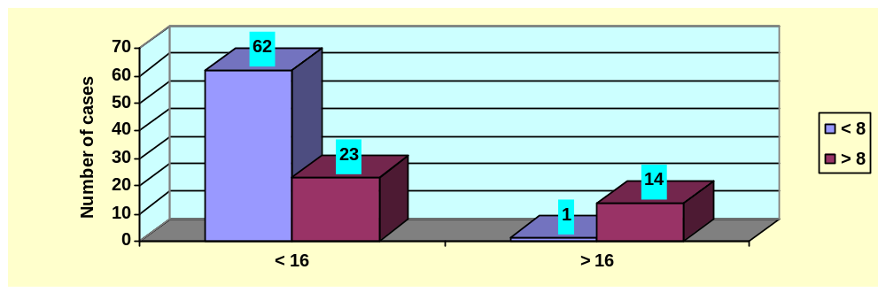Figure (31): Differentiation of the patients according to
the E/E´- L in relation to left ventricular end diastolic pressure (LVEDP).

Table (16): Validity of E/E´- L in prediction of left ventricular end diastolic pressure.

Validity of E/E` – L in prediction of LVEDP
72.9 % | Sensitivity
93.3 % | Specifity
98.4 % | PV +ve
37.8 % | PV –ve
76 % | Accuracy

PVP: predictive value positive , PVN: predictive value negative.

Kappa±SE = 0.41±0.08 {P =0.001}

The table shows high sensitivity, specifity and accuracy of E/E´- L in prediction of left ventricular end diastolic pressure, So it can be used as a predictor for left ventricular end diastolic pressure.

Table (17, 18): Show difference between E/E′-L, DF, and LVEDP by one
LVEDP | DF | E/E′-L
5.8 ± 3.43 | 0.31 ± 0.24 | less than 8
10.94 ± 3.29 | 0.27 ± 0.11 | Equal to or more than 8, but less than 15
24.09 ± 9.39 | 0.08 ± 0.07 | Equal to or more than 15
way ANOVA.

 |  | F | Sig.
DF |  | 5.508 | 0.006*
LVEDP |  | 80.123 | 0.000**

There is significant difference between different groups regarding DF,
There is highly significant difference between different groups regarding LVEDP.

- Driving force (DF):
Receiver operating characteristics (ROC) curve analysis yielded an optimal DF cutoff value of 0.1newton.
Table (19): Differentiation of the patients according to
the driving force (DF) in relation to left ventricular end diastolic pressure (LVEDP).
LVEDP |  | DF
≥16 | 16>
2 | 80 | 0.1 <
13 | 5 | ≤ 0.1

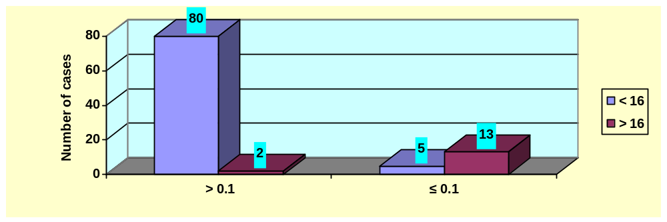Figure (32): Differentiation of the patients according to
the driving force (DF) in relation to Left ventricular end diastolic pressure (LVEDP).

Table (20): Validity of driving force in prediction of left ventricular end diastolic pressure.
Validity of DF in prediction of LVEDP
94.1 % | Sensitivity
86.7 % | Specifity
97.6 % | PV +ve
72.2 % | PV –ve
93 % | Accuracy

DF: driving force, PVP: predictive value positive, PVN: predictive value negative.

Kappa±SE = 0.74±0.09 {P >0.001}

The table shows high sensitivity, specifity and accuracy of driving force in prediction of left ventricular end diastolic pressure, so it can be used as a predictor for left ventricular end diastolic pressure.

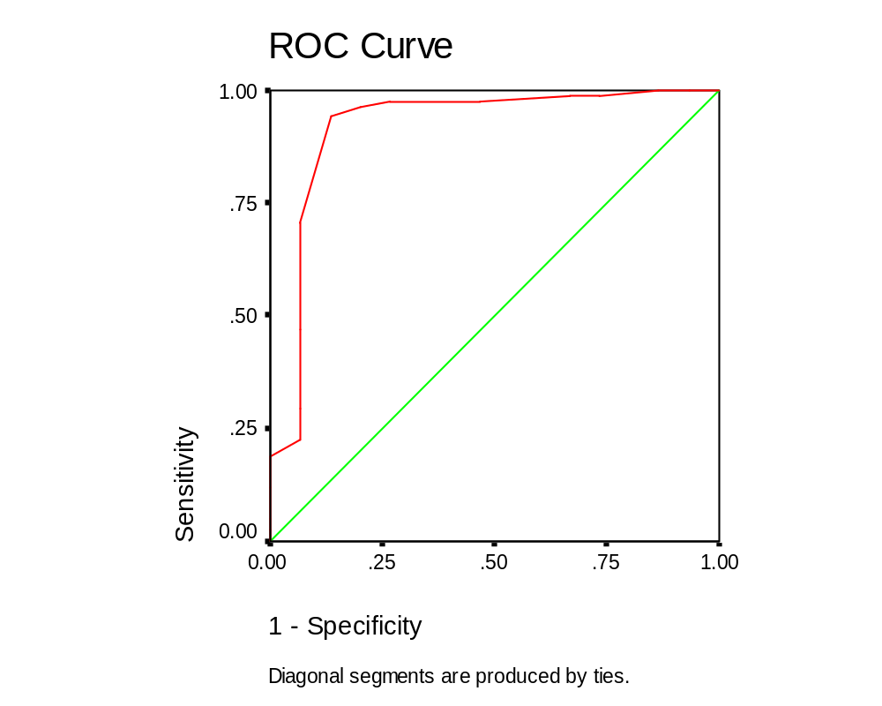 Figure (33): ROC (Receiver operating characteristics) curve of DF.

Area under the Curve (table 21):

Test Result Variable(s): DF
Asymptotic 95% Confidence Interval |  | Asymptotic Sig.(b) | Std. Error(a) | Area
Upper Bound | Lower Bound | Asymptotic Sig.(b) | Std. Error(a) | Area
1.022 | .818 | .000 | .052 | .920
The test result variable(s): DF has at least one tie between the positive actual state group and the negative actual state group. Statistics may be
biased.
a Under the nonparametric assumption
b Null hypothesis: true area = 0.5
ROC analysis yielded an optimal DF cutoff value of 0.1 newton for prediction of LVEDP >16mmHg with a sensitivity of 94.1%, a specificity of 86.7%, a positive predictive value of 97.6% and a negative predictive value of 72.2%.

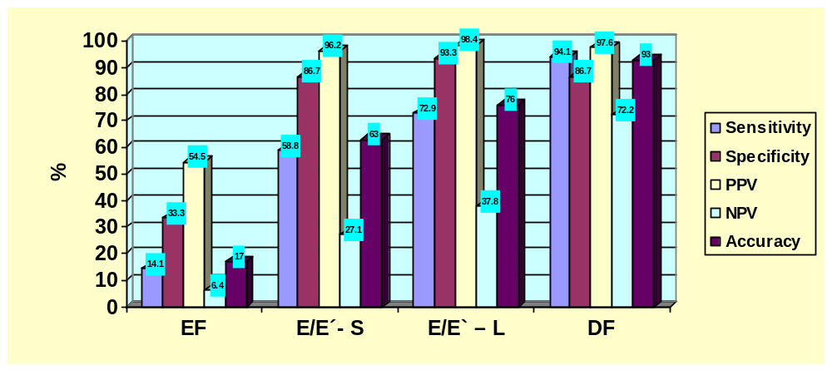
Figure (34): Comparison between EF, E/E´-S, E/E´-L, DF in prediction of LVEDP.

Thus, we can conclude that:
- EF cannot be relied on as a predictor of LVEDP despite significant negative correlation.
- E/E´-L is more sensitive and specific than E/E´-S in prediction of LVEDP.
- DF is more sensitive than E/E´-S and E/E´-L.
DF has equal specifity of E/E´-S, but less specific than E/E´-L.

Table (22, 23): Shows stepwise logistic regression analysis of significant variables.

Parameter Estimates
LVEDPª |  | B | Std. Error | Wald | df | Sig. | Exp(B) | 95% Confidence Interval for Exp(B)
 |  |  |  |  |  |  |  | Lower Bound | Upper Bound
 | Intercept | .577 | .371 | 2.421 | 1 | .120
 | HTN | 1.390 | .713 | 3.806 | 1 | .051 | 4.015 | .994 | 16.225
 | DM | 1.857 | .814 | 5.211 | 1 | .022 | 6.406 | 1.300 | 31.561
a. The reference category is: 1.00. >16
b. This parameter is set to zero because it is redundant.

Parameter Estimates
LVEDPª |  | B | Std. Error | Wald | df | Sig. | Exp(B) | 95% Confidence Interval for Exp(B)
 |  |  |  |  |  |  |  | Lower Bound | Upper Bound
 | Intercept | 1.057 | 1.312 | .649 | 1 | .420
 | E/E´-S | 13.920 | 1.348 | 16.640 | 1 | 0.04 | 9.012E-007 | 6.419E-008 | 9.265E-005
 | E/E´-L | 17.938 | 1.000 | 155.3 | 1 | 0.02 | 611.744 | 6.1.744 | 8.2.746
 | DF | -4.243- | 1.353 | 9.841 | 1 | 0.002 | .014 | .001 | .203
a. The reference category is: 1.00.
b. This parameter is set to zero because it is redundant.
<0.05 SIG

After applying regression analysis, the present study showed that early diastolic driving force (DF) is the most significant independent variable in prediction of LVEDP. Also, E/E´-L, E/E´-S, diabetes mellitus but not hypertension are independent predictors of LVEDP.

Intra-observer correlation:
Non invasive parameters were measured by the same echocardiographer two weeks after the first echocardiographic examination for ten random cases, showed statistically high significant correlation between similar parameters(table 24, figure 35,36,37).
Table (24): Intra observer correlation of E/E`-S, E/E`-L, DF.

P | R
0.001> | 0.95 | E/E`-S
0.001> | 0.82 | E/E`-L
0.001> | 0.79 | DF

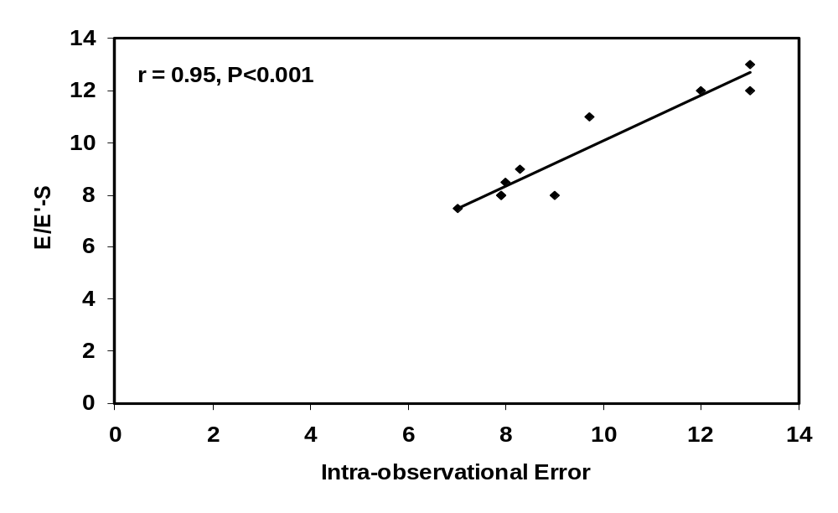
Fig. (35): Intra observer correlation of E/E`-S.
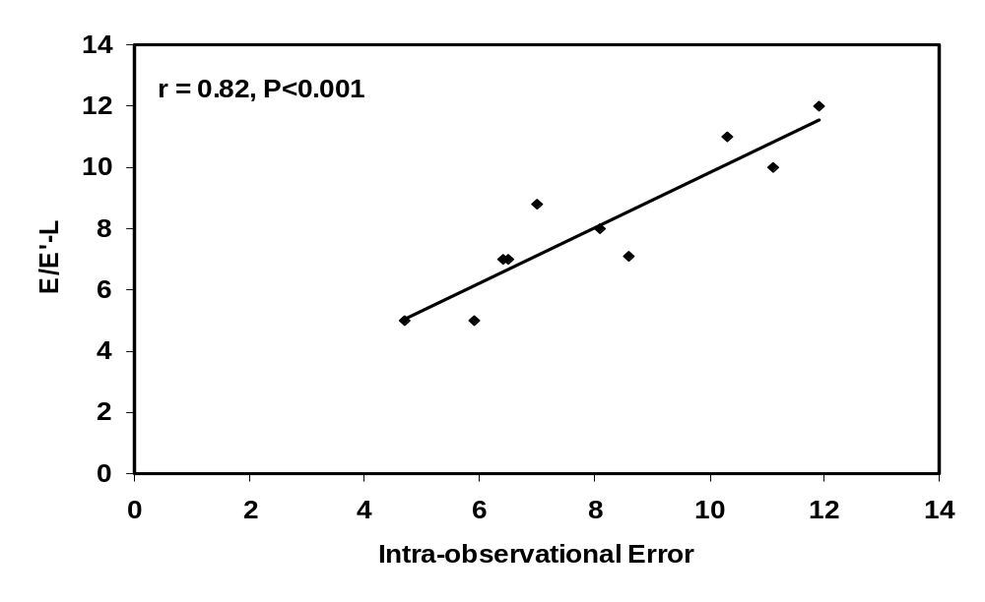
Fig. (36): Intra observer correlation of E/E`-L.
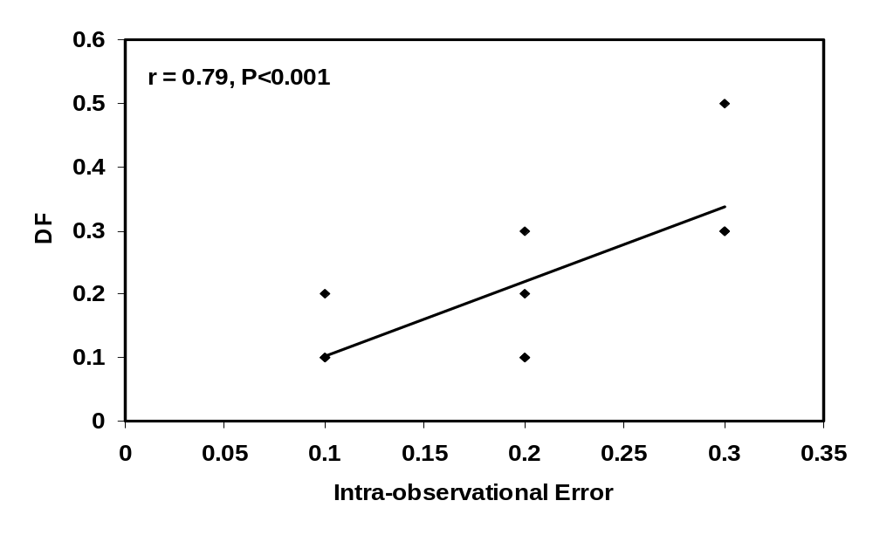

Fig. (37): Intra observer correlation of DF.

Inter-observer correlation:
Non invasive parameters were measured by the another echocardiographer for ten random cases , showed statistically high significant correlation between similar parameters(table 25, figure 38,39,40).
Table (25): Inter observer correlation of E/E`-S, E/E`-L, DF.
p | r
0.001> | 0.91 | E/E`-S
0.001> | 0.75 | E/E`-L
0.001> | 0.68 | DF

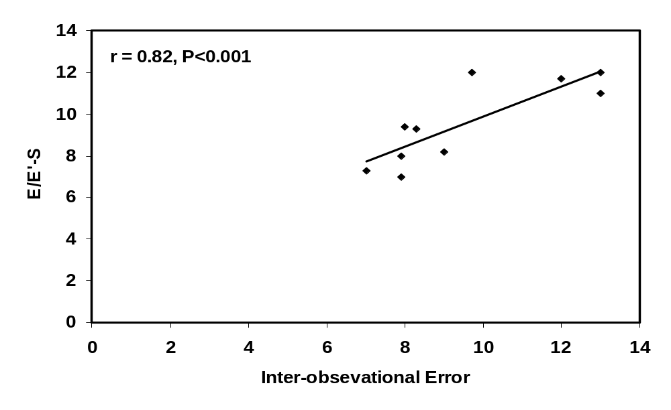
Fig. (38): Inter observer correlation of E/E`-S.

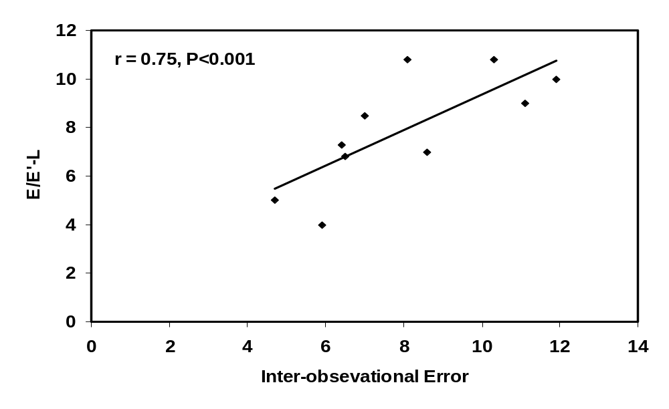
Fig. (39): Inter observer correlation of E/E`-L. 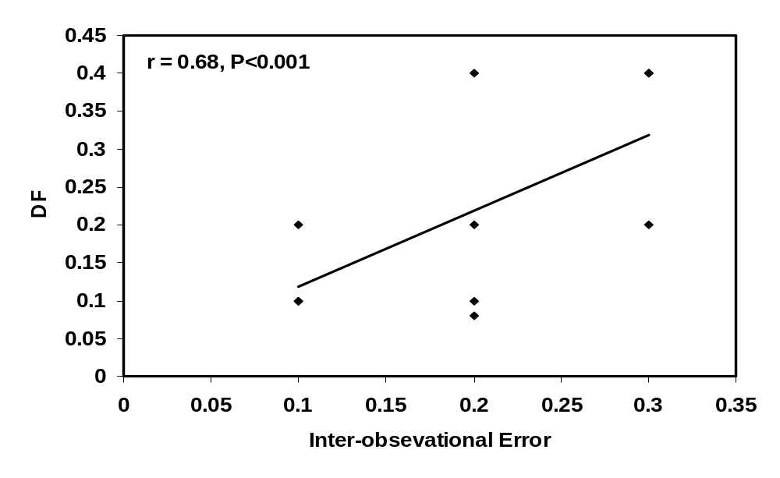
Fig. (40): Inter observer correlation of DF.

Table (26) showing statistically non significant intraobserver, interobserver error.

Interobservational |  | Intraobservational
p | error | p | error
0.98 | 0.01 | 0.6 | 0.12 | E/E`-S
0.8 | - 0. 13 | 0.9 | 0.04 | E/E`-L
0.35 | 0.03 | 0.24 | 0.032 | DF

